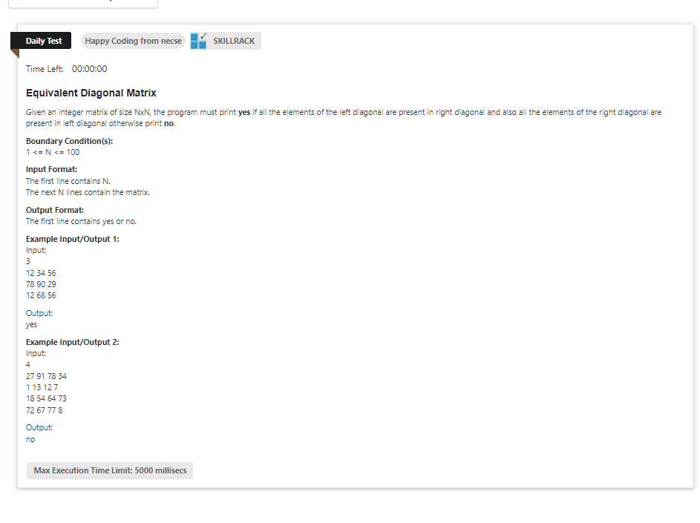

import java.util.\*;

public class Main {

public static void main(String[] args) {

Scanner sc=new Scanner(System.in);

int n=sc.nextInt();

int[][] arr=new int[n][n];

int lf[]=new int[n];

int rt[]=new int[n];

int k=0;

int l=0;

for(int i=0;i<n;i++){

for(int j=0;j<n;j++){

arr[i][j]=sc.nextInt();

if(i==j){

lf[k++]=arr[i][j];

}

if((i==0 && j==n-1)||(i==n-1 && j==0) || (i==n/2 && j==n/2)){

rt[l++]=arr[i][j];

}

}

}

int c=0;

System.out.println(Arrays.toString(rt));

System.out.println(Arrays.toString(lf));

for(int i=0;i<n;i++){

for(int j=0;j<n;j++){

if(rt[i]==lf[j]){

c++;

}

}

}

System.out.println(c);

if(c==n){

System.out.println("yes");

}

else{

System.out.println("no");

}

}

}